**9-Dec-2024**

**Internship Day - 96 Report:**

**Exercise 5: (Adhoc Commands in Ansible)**

<https://docs.ansible.com/ansible/latest/command_guide/intro_adhoc.html>

**change the hostname of your all machines if u want**

**Manage Packages Commands:**

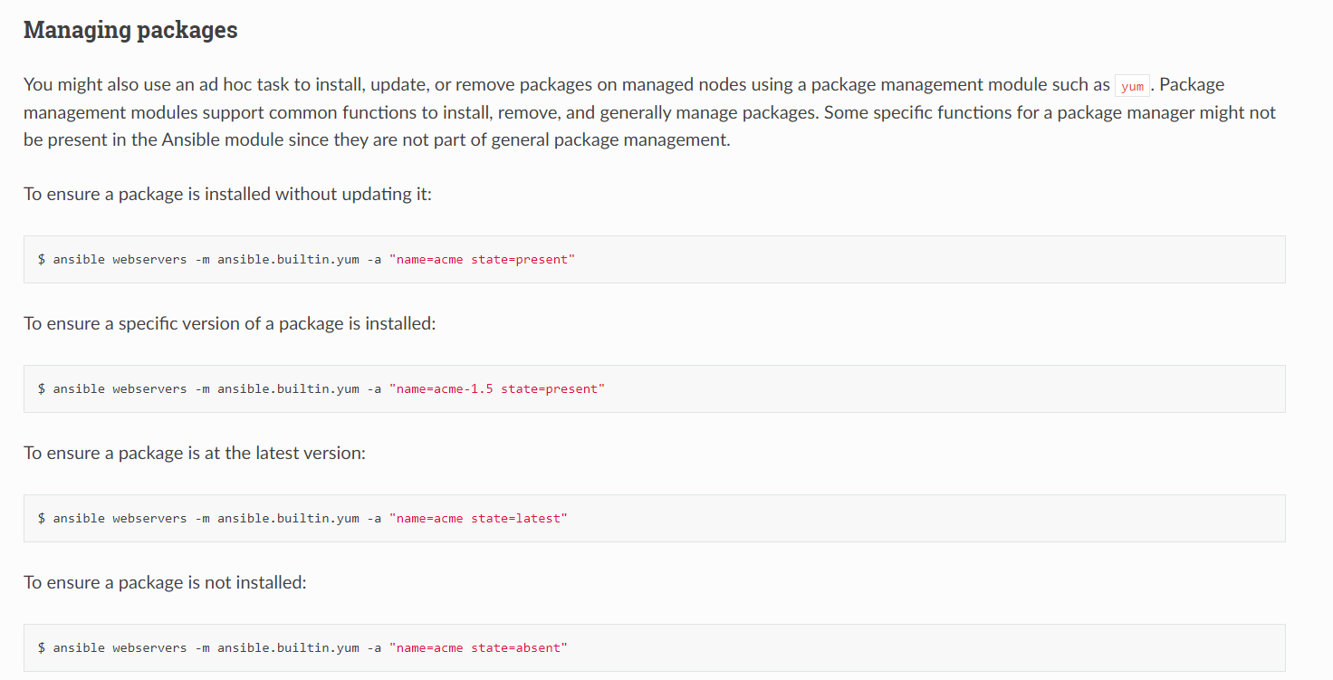

**For install:**

ansible <machine-name> -m ansible.builtin.yum -a "name=<webserver-name> state=present"

**appu nu become lgana penda ehnu run karn leyi (become means sudo/root user)**

ansible web001 -m ansible.builtin.yum -a "name=httpd state=present" –become

**output ist time:**

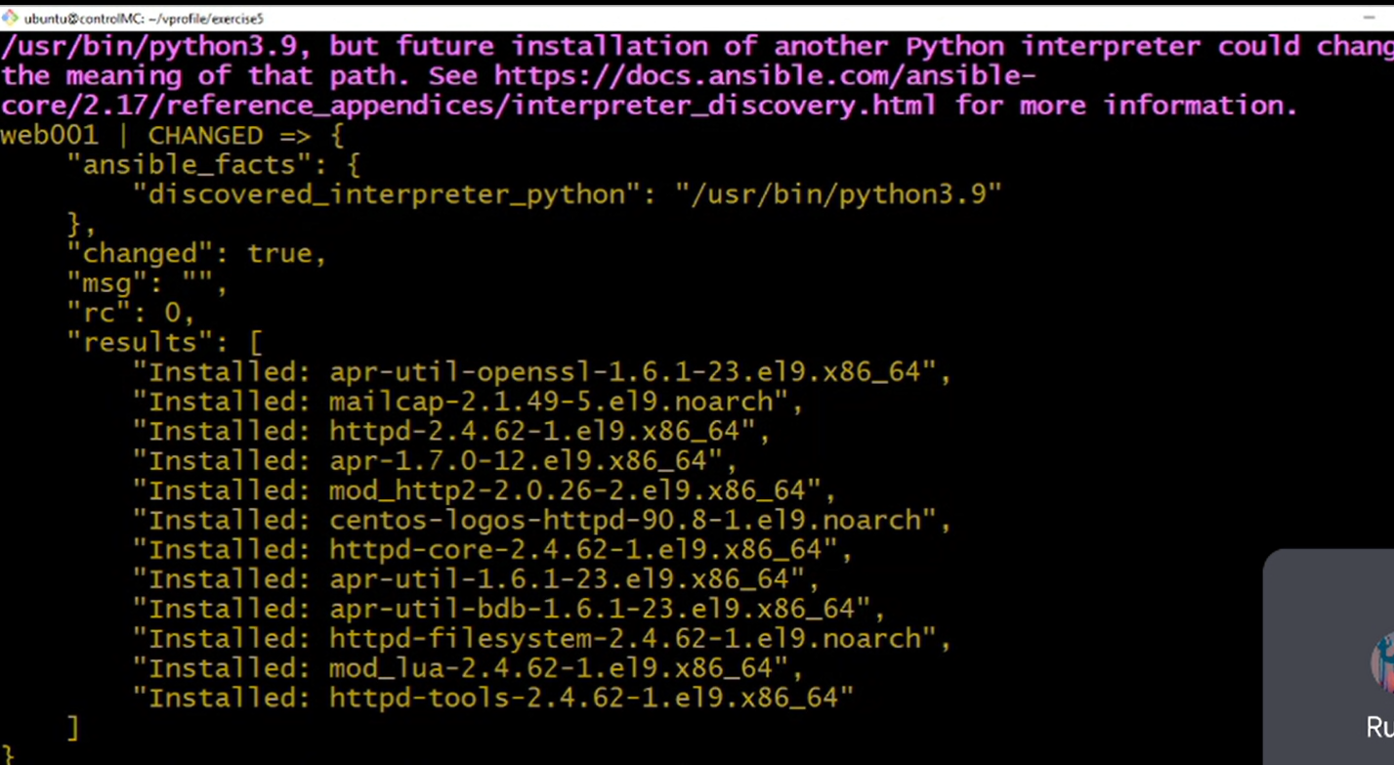

2nd time run karn ch khduga eh already done aa

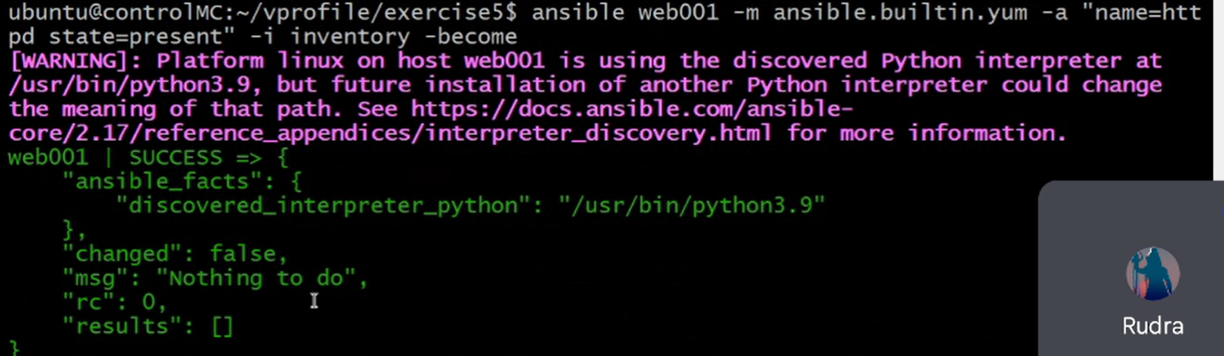

**For remove/ delete:**

ansible web001 -m ansible.builtin.yum -a "name=httpd state=absent" –become

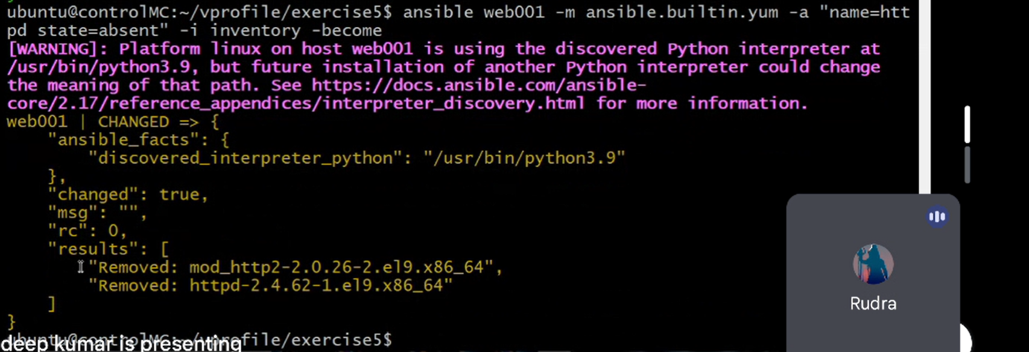

**Server on / off command:**

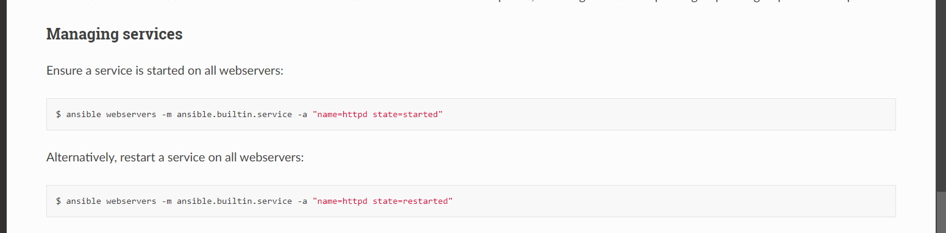

**ansible web001 -m ansible.builtin.service -a "name=httpd state=started" –i inventory –b**

**Output:**

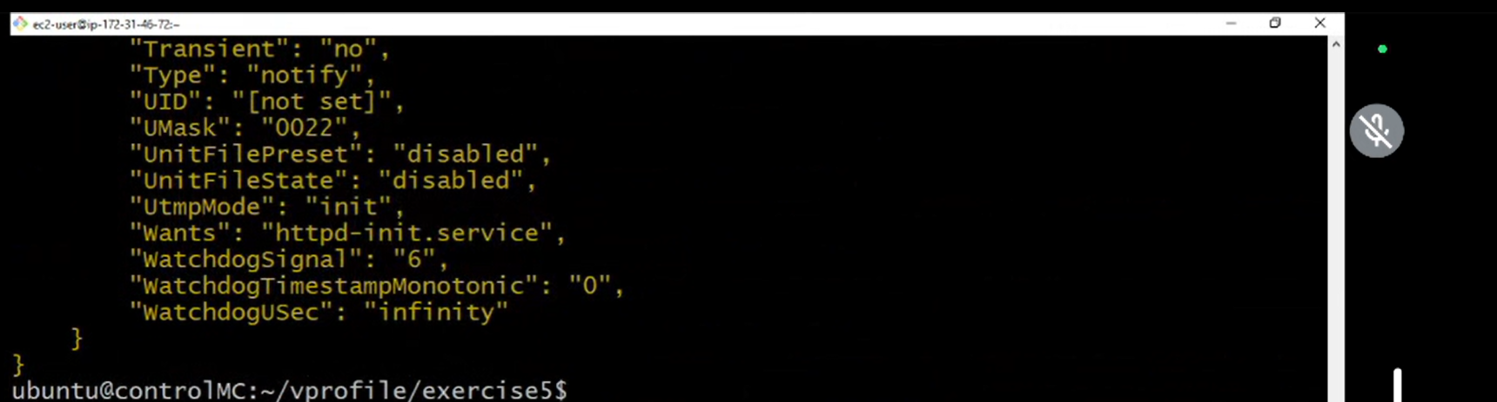

**Now hun je appa ek group ch install krni howe services --- and yeh kisi ch install hegi aa tah thik aa yeh nnhi aa tah install krdu service --- agr sbb ch install aa tah kise ch kuch nhi kru**

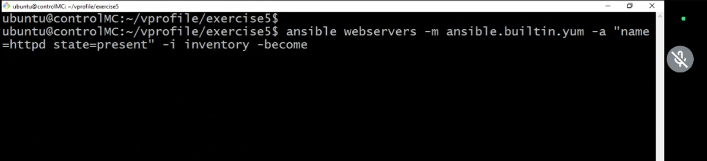

**Output:**

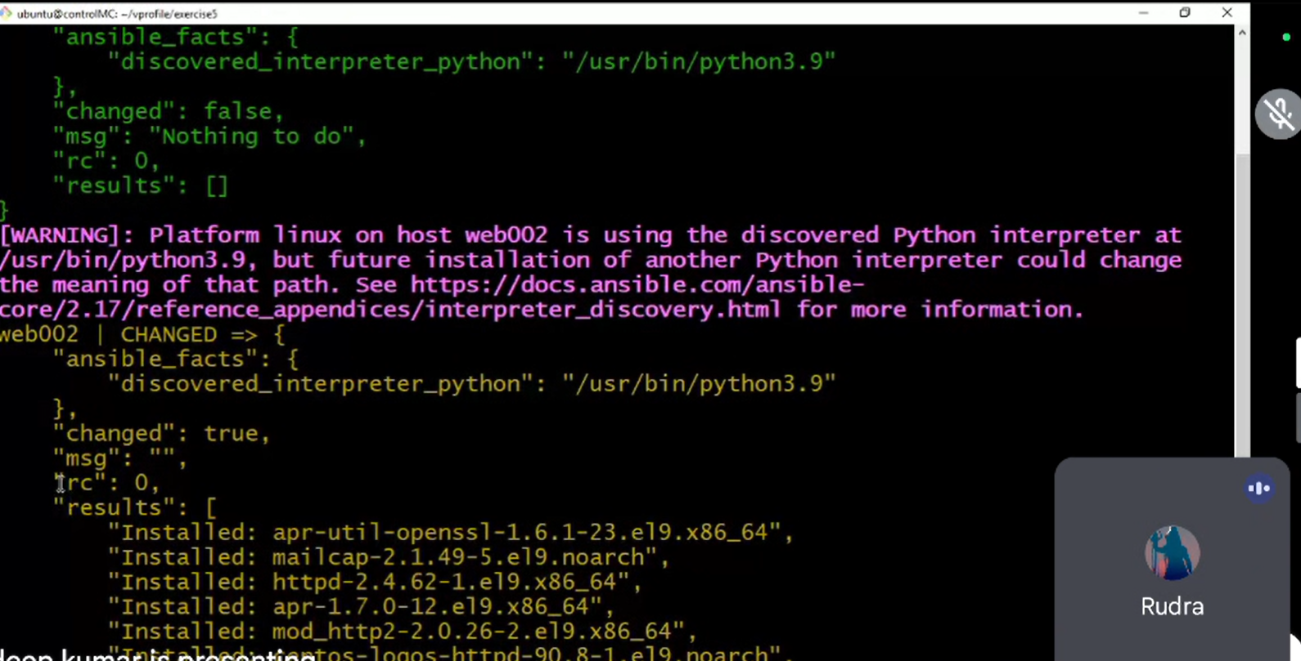

**Browser o/p:**

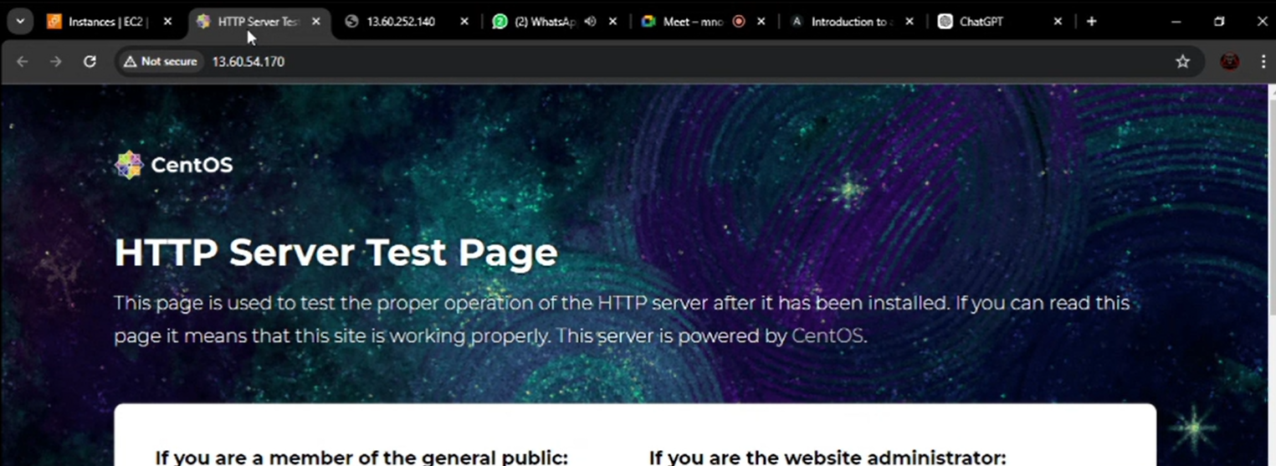

**For remove service in group:  
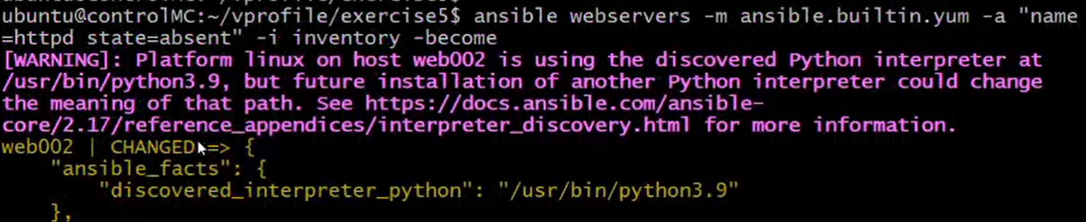**

**10-Dec-2024**

**Internship Day - 97 Report:**

**Exercise 5:**

**File and project deploy using Ansible :**

Machines nu http protocols allow krni security ch



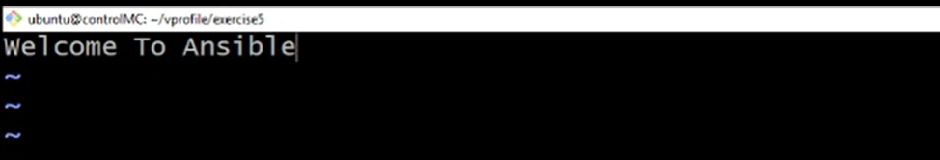

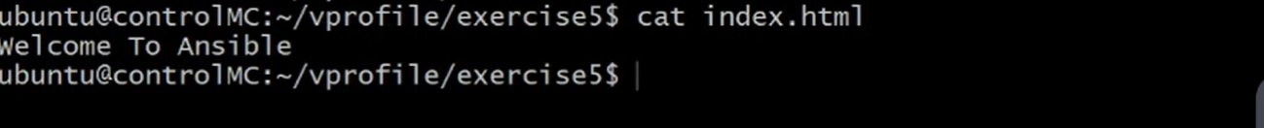

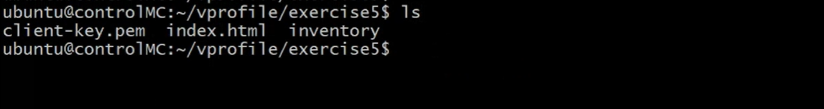

**Copy krna project /var/www/html location ch**

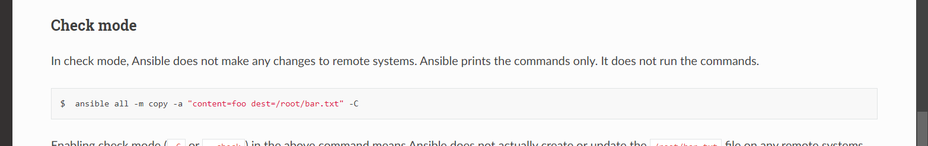

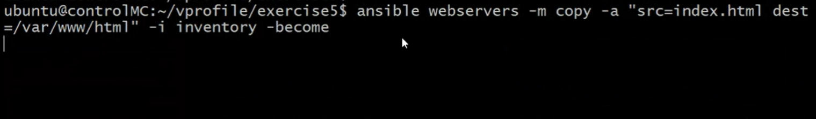

**Output:**

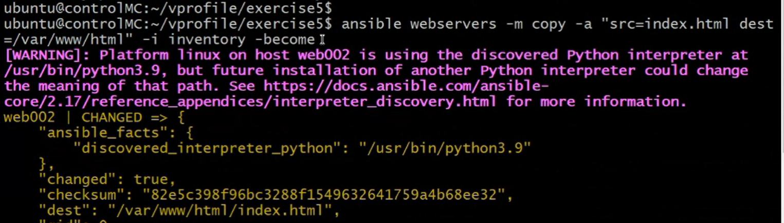

**Done uploading:**

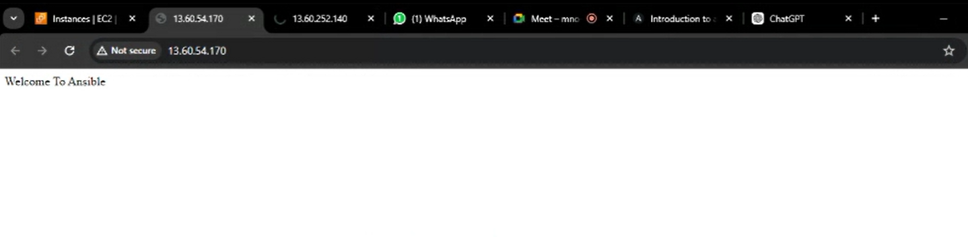

**11-Dec-2024**

**Internship Day - 98 Report:**

**Playbook file**

<https://docs.ansible.com/ansible/latest/playbook_guide/playbooks_intro.html>

## **What are playbooks?**

Ansible is an orchestration tool. It needs a list of tasks/instructions to perform on the machines listed in the inventory file. You can execute a task with Ansible more than once using a playbook. **Playbooks** offer repeatable, reusable, simple configuration management. It can be used for configuration management, orchestrating steps of any manual process on multiple machines in synchronous or asynchronous order.

A playbook is written in YAML format. It is composed of one or more 'plays' in an ordered list. And one play contains a set of tasks that runs on a group of machines.

## **Different YAML Tags**

Let us now go through the different tags in a playbook-

* **name:** Logical name of the task which specifies what this playbook will be doing
* **hosts:** This specifies the lists of hosts against which we want to run the task
* **vars:** This allows you to define and use variables in your playbook
* **tasks:** Tasks are a list of actions the playbook will perform

In an ad-hoc command setup, we need to run commands repeatedly to achieve the same configuration on different machines. This means we have to manually execute commands every time we want to make changes or ensure consistency.

However, with a **playbook file**, we can write the commands in a file and use it to execute the desired tasks on multiple machines in one go. This approach saves effort and ensures consistency across all machines, as the same playbook file can be reused whenever needed.

Essentially, by creating and keeping a **playbook file**, we can streamline the process and use it whenever required instead of running ad-hoc commands repeatedly.

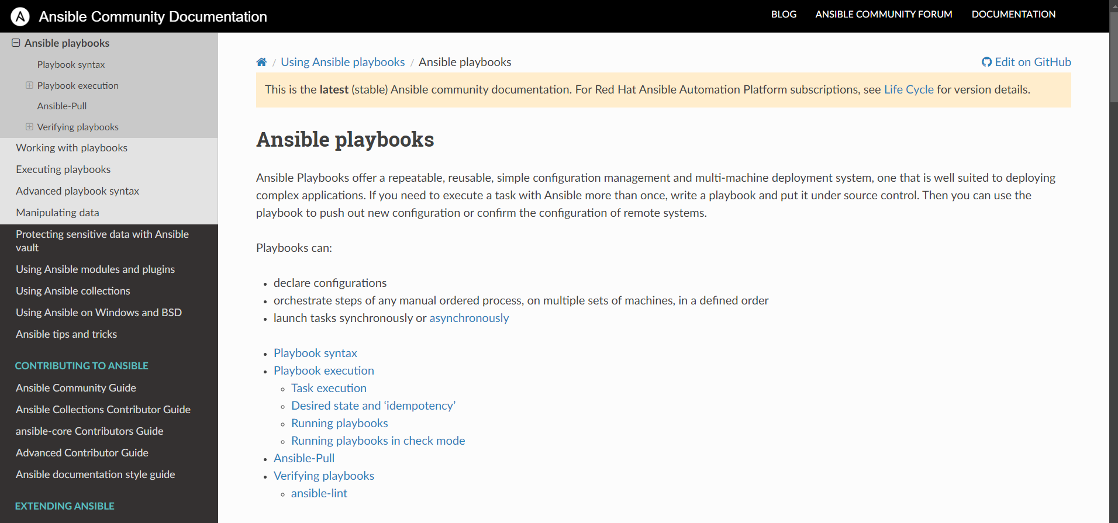

**Exercise 6:**

1. **Make a playbook yaml file**

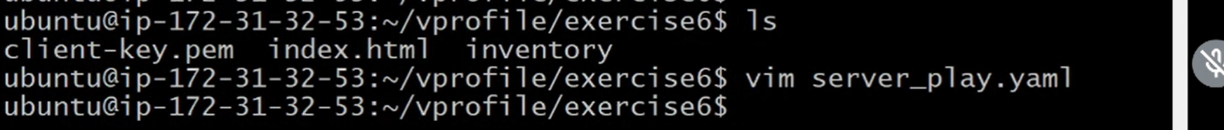

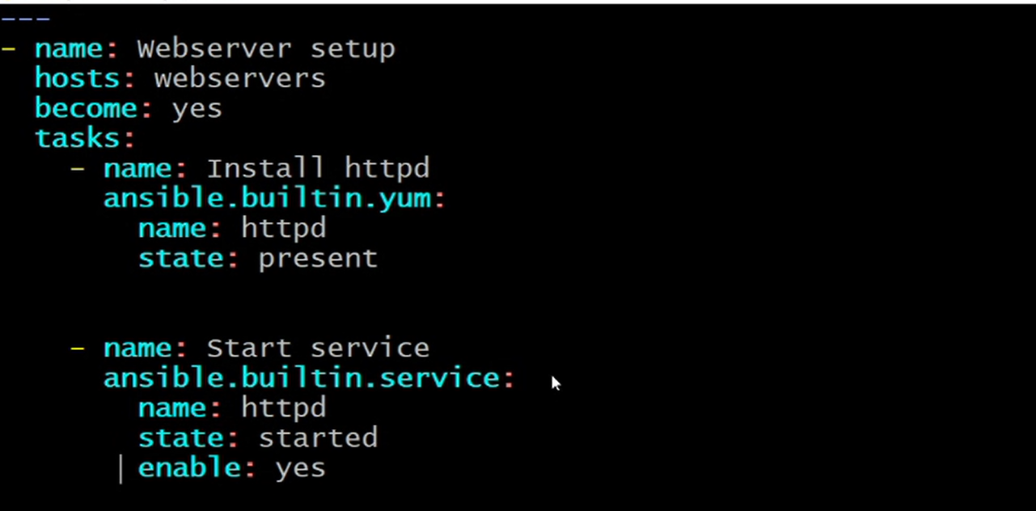

1. **Run the command:**



**Ansible-playbook –I inventory <playbook-file-name>**

1. **Output:**

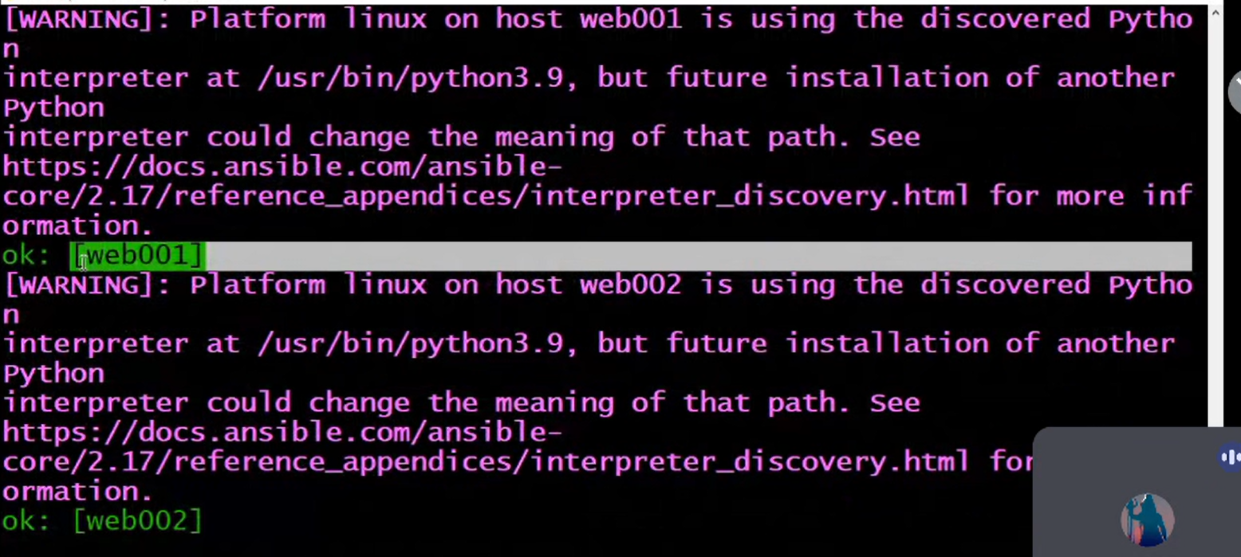

1. **Readable Form:**

To make the output more readable and detailed, you can use the **-v** option (verbose mode) with the ansible-playbook command.

**Command:**

**ansible-playbook -i inventory <playbook-file-name> -v**

**12-Dec-2024**

**Internship Day - 99 Report:**

**Exercise 7:**

**In playbook file add lines For Dbserver**

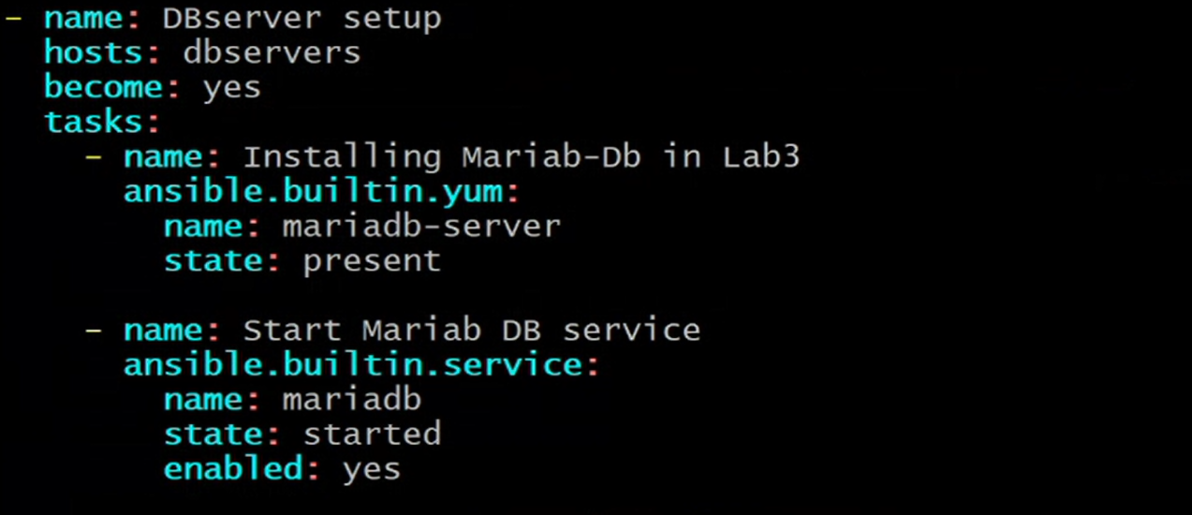

**Run the command:**



**Output:**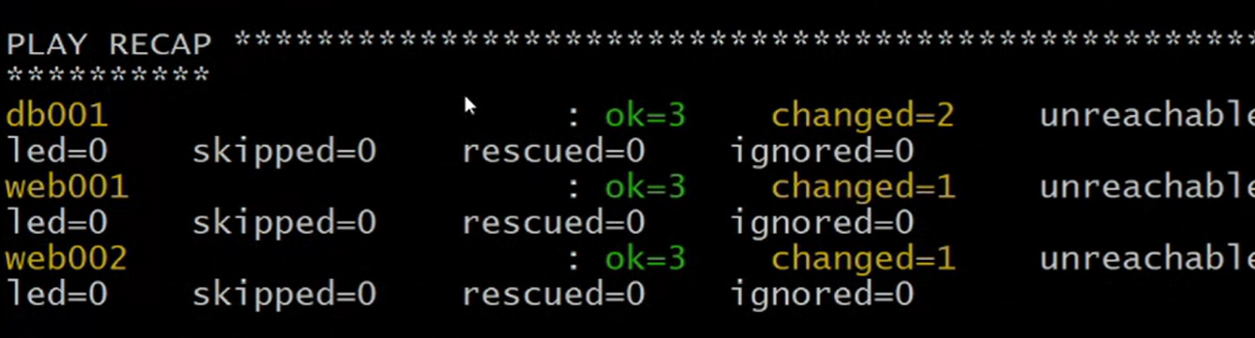

**Exercise 8: (super global variable bnane sikhange)**

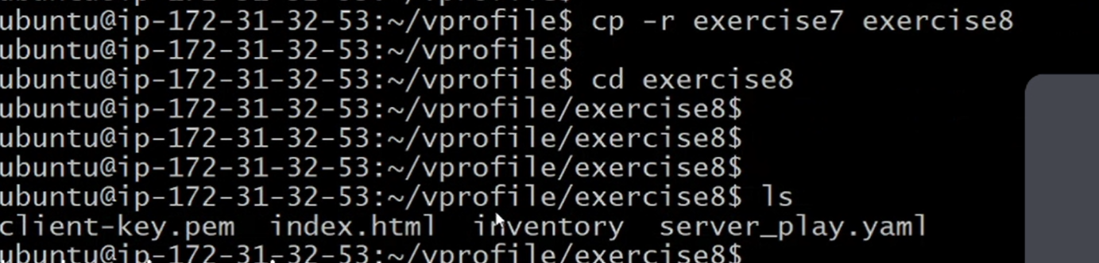

**Make a** group_vars **directory.. it is predefined !**



**Ls**



**Cd group_vars**

**Touch all (all file is complousary bnania kyuki playbok file nu access krn leyi)**

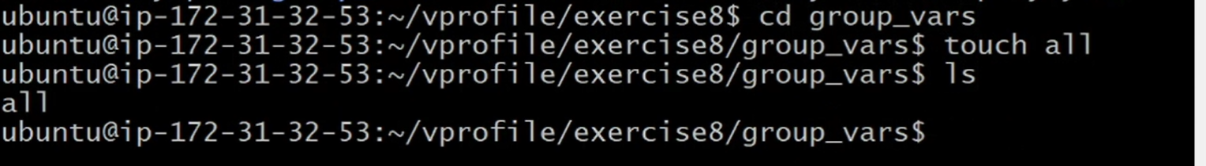

**Vi all**

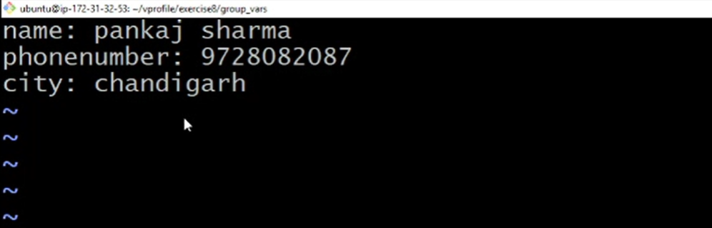

**Cat**

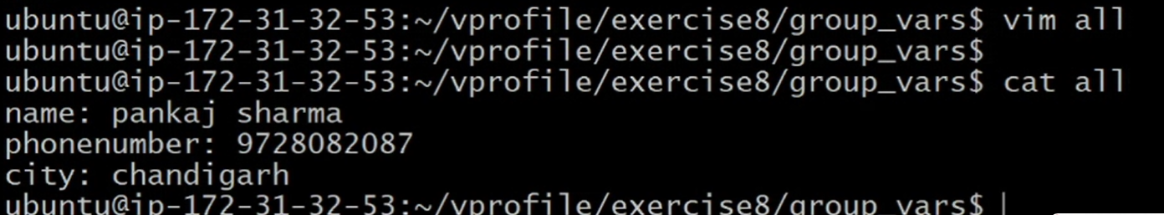

**Now hun aapa playbook file edit krange**

**Debug predefined variable use krange and ek time ch ek hi msg print ho skda**

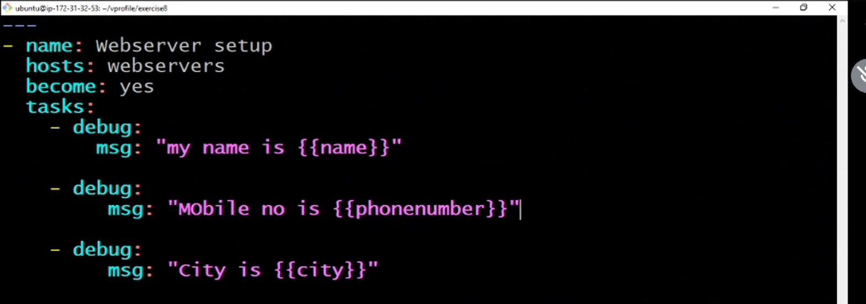

**Now run the file:**

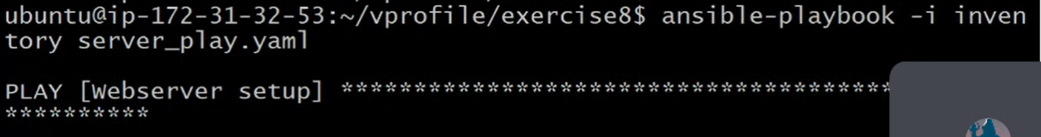

**Output:**

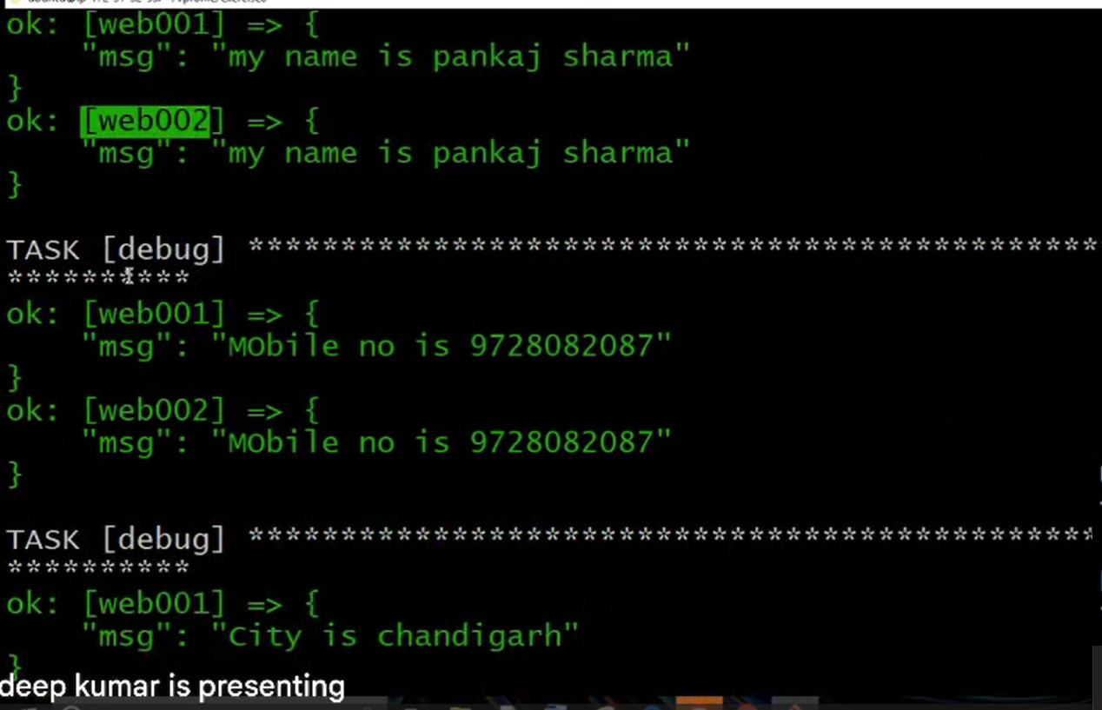

**13-Dec-2024**

**Internship Day - 100 Report:**

**Main imp:**

**If ur variables is also present in playbook file (grup_vars – all de nal nal)**

**Then ansible phle tuhade playbook aale variables chku ga then all file aale super global variables chkkuga**

